Assignment 2-Case Study

Stage 4 Lab Activities

Implementing the SmartCare Domain Layer
DESIGN FIRST -> AI PAIR PROGRAMMING -> REVIEW -> VERIFY | 1hour

A - Revisit Approved UML
Confirm responsibilities, attributes and relationships before coding

Appointment
Patient
Practitioner
1
1
0*
0*
-appointmentTime: DateTime
-status: String
+isComplete():boolean
+cancel():void
+isActive():boolean
-patientId:String
-name:String
+getName():String
+matchesId(id):boolean
-name:String
+getName():String
+isBusyAt(time):boolean
Relationships are all the same as before but C in this lab describes practitioners as needing an identifier and specialty to be listed which was not stated anywhere in the initial brief from the client and will have to be added. I will assume that appointment only needs to reference name and not identifier or specialty which will only be used when using the searching function. Patient will also need to have a getPatientid():String

B - Implement Patient: AI OFF
Implement Patient with type hints and basic validation.

C - Implement Practitioner: AI OFF
Implement Practitioner with identifier, name and specialty; no database logic.
Both B and C are done to see it pre asking copilot to make appointment check Smartcare_clinic_basicimplementation_beforeAi

D - Implement Appointment: AI ON
Give AI the approved Appointment UML, business rules and explicit constraints. Ask it to implement only Appointment and agreed enum/exception.

E - Review Generated Code
Check model consistency, unsupported features, public state mutation, unnecessary inheritance, invented dependencies and error handling.
Model consistency is mostly consistent although Copilot removed the ability to set status of an appointment when it is made which makes sense since you would never create a cancelled appointment.
No unsupported features are added although it did suggest an appointment repository and scheduling service again which I already rejected.
Public state mutation is fine
No unnecessary inheritance as exception and enum base classes are required.
No invented dependencies except from enum import Enum which is fine.
Error handling is ok but if not patient only checks if something was passed. A plain string would pass the crash later with an attribute error.

F - Manual Behaviour Checks
Create valid objects, test invalid input, cancel a scheduled appointment and attempt an illegal repeated transition.
Main has to be edited to allow you to book multiple appointments because you can currently only book 1
You can now book appointments. 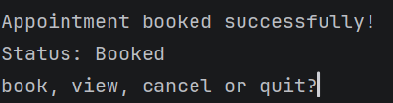
View your currently booked appointments.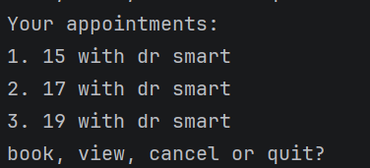
Cancel any of your currently booked appointments.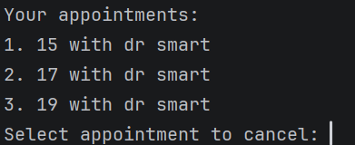
And quit the menu. 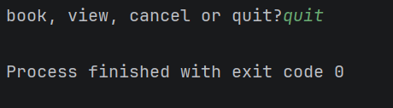
Typing something other than book, view, cancel or quit in that menu replies with invalid input. 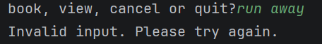
If you have no appointments to cancel or view the code will inform you of that. 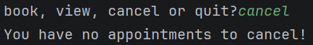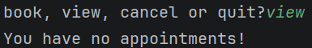
Trying to select an appointment that doesn't exist to cancel or by not writing a number gives you the response of please enter a valid number.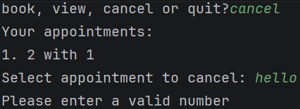
If you attempt to book an appointment that is already booked it will fail.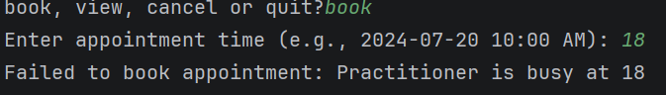
With this code it is impossible to cancel an appointment that is already cancelled as the cancel screen only shows active appointments.

G - Refactor
Remove unnecessary code and make implementation simpler and design-consistent.
Code from ai can be found in Ai_usage_stage4 and the final code can be found in Smartcare_clinic_basicimplementation_postAi
Main had to be edited to allow you to book multiple appointments because before you could only only book 1
To make the code simpler I can remove the banner comments and a few other comments that Copilot added as they don't explain the code and don't serve a purpose outside of talking to me.
I can remove the InvalidStatusTransitionError class as it is not required since you can't attempt to cancel already booked appointments.
I also decided to remove the is_complete() as it never activates

H - AI Engineering Log
Record prompt, generated contribution, decisions and verification evidence.
Prompt is in Ai_prompt_stage4 and used on copilot set to smart
Output is in Ai_usage_stage4

Item | Decision | why
InvalidStatusTransitionError | Rejected | Was useless
is_complete() | Rejected | Was useless
Main | modified | Changed to a book, view, cancel, quit loop so you could actually view, create and cancel multiple appointments.
Copilots comments | Rejected | Copilot added a bunch of comments explaining why it added things but not useful for explaining what the code does
Two value appointment status enum | Accepted | Matches my UML and so i kept what was generated.
Constructor checks for a busy practitioner and missing fields | Accepted | Matches my crc cards.

Verification evidence can be found in part F

Suggested AI prompt
Act as a Python pair programmer. Implement only the Appointment class from the approved SmartCare UML. Use type hints and an AppointmentStatus enum. Cancelled appointments remain as objects. Do not add database, UI, notification or service classes. Protect status transitions and explain any decision not directly visible in the UML.

Reflection
Which AI-generated part did you modify or reject? Why? How did the approved design constrain the AI?
I modified the main Copilot generated in order to allow multiple bookings and the ability to cancel and view those bookings as Copilots main lacked these things.. Copilot generated its code with 2 useless items which were the Invalid status transition and iscomplete() which both never activated and just led to the code being more difficult and confusing to read. Copilot did follow my instructions which forced it to do things like not have prints or inputs inside the domain classes and built the busy check that I specified to it. Copilot did still try to offer suggestions which I didn't want in its closing messages such as repositories and services as well as drop the status parameter which it didn't bring up or explain. The Ai followed the parts of the design that were explicit and rigid like rules but drifted on things left more open ended.

